**CSA 0563 – DBMS**

**Cretaing a table by using CREATE**

CREATE TABLE STUDENT2

(

name VARCHAR(10),

std_id NUMBER(10),

age NUMBER(2),

course VARCHAR(10),

date_of_registration DATE

);

Inserting values into table by Using INSERT keyword

INSERT INTO STUDENT2 (name,std_id,age,course,date_of_registration)

VALUES ('ELIYAZAR',192311162,19,'DBMS',TO_DATE('10-07-2024','DD-MM-YYYY'));

INSERT INTO STUDENT2 (name,std_id,age,course,date_of_registration)

VALUES ('CHANIKYA',192311164,18,'DBMS',TO_DATE('10-06-2024','DD-MM-YYYY'));

INSERT INTO STUDENT2 (name,std_id,age,course,date_of_registration)

VALUES('CHANIKYA',192311164,18,'DBMS',TO_DATE('10-06-2024','DD-MM-YYYY'));

INSERT INTO STUDENT2 (name,std_id,age,course,date_of_registration)

VALUES('PRAKASH',192311165,19,'JAVA',TO_DATE('10-06-2024','DD-MM-YYYY'));

INSERT INTO STUDENT2 (name,std_id,age,course,date_of_registration)

VALUES('POLI',192311166,19,'JAVA',TO_DATE('11-07-2024','DD-MM-YYYY'));

INSERT INTO STUDENT2 (name,std_id,age,course,date_of_registration)

VALUES('VICKY',192311161,20,'DBMS',TO_DATE('10-07-2024','DD-MM-YYYY'));

**Displaying the tablevalues by using** **SELECT**

SELECT *

FROM STUDENT2;



Appluying condition **WHERE**

SELECT name ,course,date_of_registration

FROM STUDENT2

WHERE std_id = 192311162;



Adding another column to a table by using ALTER and ADD

ALTER TABLE STUDENT2

ADD marks FLOAT;

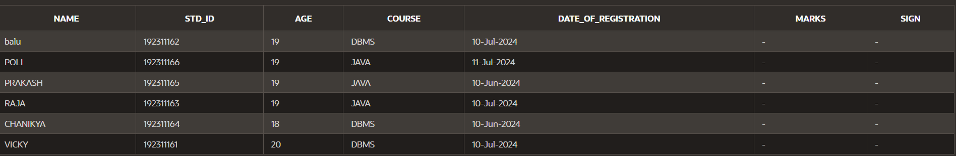

Deleting column name by using ALTER and DROP

ALTER TABLE STUDENT2

DROP (sign);

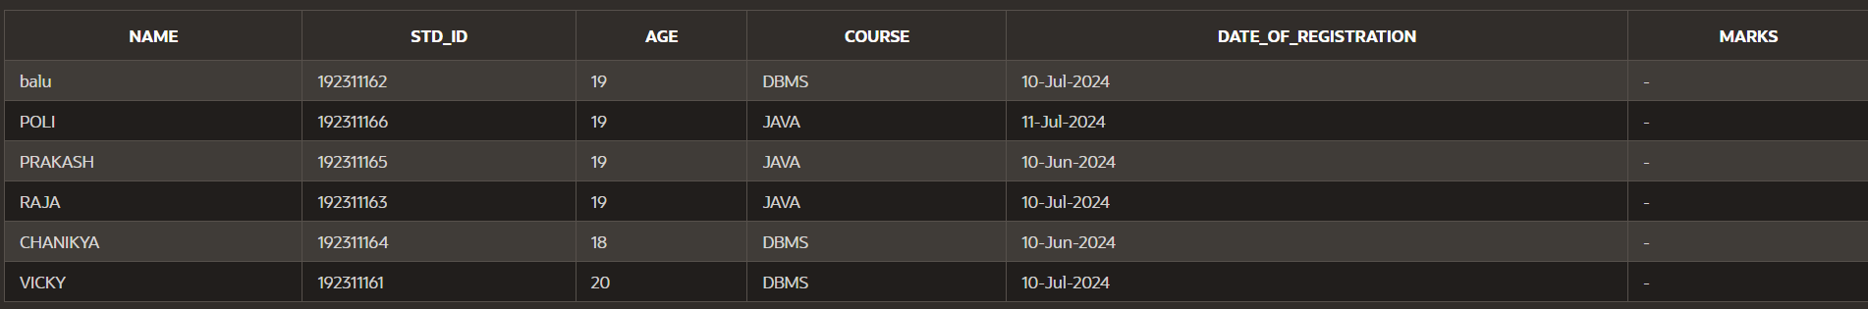

Updating the specified row in a table by using UPDATE,SET

UPDATE STUDENT2

SET name=’balu’

WHERE std_id=192311162;



Deleting specifed row in a table by using DELETE keyword

DELETE FROM STUDENT2

WHERE name=’PRAKASH’

SELECT * FROM STUDENT2



Deleting all the rows in a table by using TRUNCATE keyword

TRUNCATE TABLE STUDENT2;

SELECT * FROM STUDENT2;



Selecting only some columns in the table by using SELECT

SELECT emp_id,first_name,salary

FROM Employee;



ARTHMETIC OPERATORS :

(+-*/)

SELECT emp_id, salary+3000

FROM Employee;



CONCATENATE two column name as one name by using AS :

SELECT first_name | | last_name AS Emp_name

FROM Employee;



DESCRIBE Keyword

desc keyword

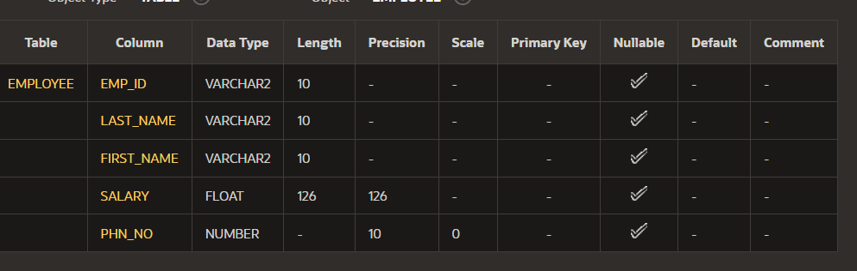

Using WHERE clause

SELECT first_name,last_name,salary

FROM Employee

WHERE salary > 50000.0;



Using BETWEEN and AND operator

SELECT first_name,last_name ,salary

FROM Employee

WHERE salary BETWEEN 35000.0 AND 75000.0;



By using IN operator

SELECT first_name,last_name,salary

FROM Employee

WHERE emp_id IN (2,5);



By using NOT IN operator

SELECT first_name,last_name,salary

FROM Employee

WHERE emp_id NOT IN (2,5);



By using LIKE operator

SELECT first_name,last_name,salary

FROM Employee

WHERE last_name LIKE ‘r%’;



By using OR operator

SELECT emp_id,first_name

FROM Employee

WHERE emp_id=’1’ OR emp_id = ‘5’;



Arranging or ordering the tablein ASCENDING and DESCENDING ORDER by using ORDER BY

SELECT emp_id,first_name,last_name

FROM Employee

ORDER BY emp_id DESC;



SELECT emp_id,first_name,last_name

FROM employee

ORDER BY last_name ;



GROUP FUNCTIONS :

MAX :

SELECT MAX(salary)

FROM Employee;



MIN:

SELECT MIN(salary)

FROM Employee;



AVERAGE :

SELECT AVG(salary)

FROM Employee;



SUM :

SELECT SUM(salary)

FROM Employee;



More than one GROUP function :

SELECT MAX(Salary),MIN(Salary),MIN(emp_id)

FROM Employee

WHERE last_name='raju';



VARIANCE :

SELECT ROUND(VARIANCE(salary),2)

FROM Employee;



STANDARD DEVIATION :

SELECT ROUND(STDDEV(salary),2)

FROM Employee;



COUNT :

SELECT COUNT(emp_id)

FROM Employee;



COUNT(*)

SELECT COUNT(*)

FROM Employee

WHERE emp_id > 2;



DISTINCT

SELECT DISTINCT last_name

FROM Employee;





SELECT COUNT(DISTINCT salary)

FROM Employee;



SELECT AVG(NVL(salary,0))

FROM Employee;



DATE CONVERSIONS :

SELECT TO_CHAR(date_of_registration 'Month dd, YYYY')

FROM STUDENT 3;



SELECT TO_CHARdate_of_registration, 'fmMonthddth, YYYY')

FROM STUDENT3;



SELECT TO_CHAR(date_of_registration, 'fmDayddthMon, YYYY')

FROM STUDENT3;

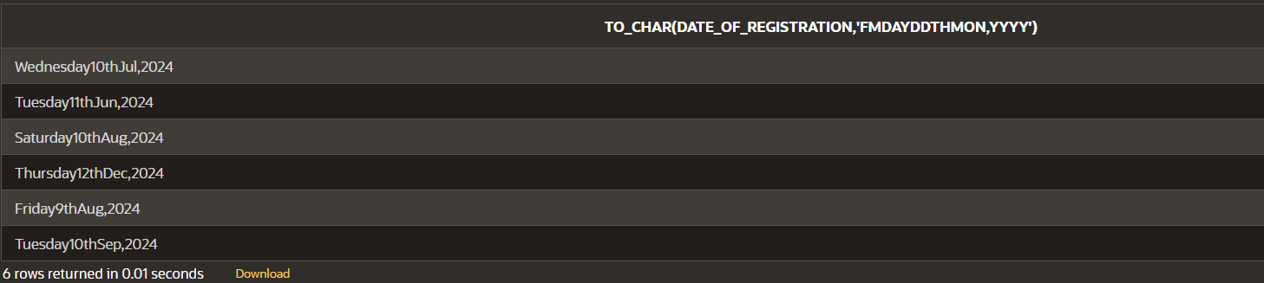

SELECT TO_CHAR(date_of_registration, 'fmDayddthspMon, YYYY')

FROM STUDENT3;

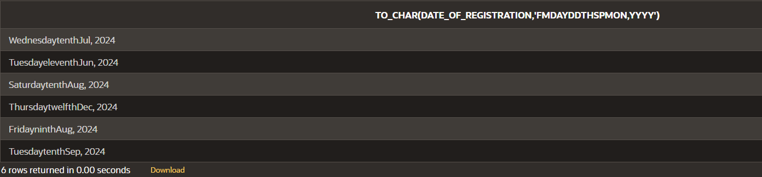

SELECT TO_CHAR(date_of_registration, 'fmDay, ddthsp "of" Month, Year')

FROM STUDENT3;

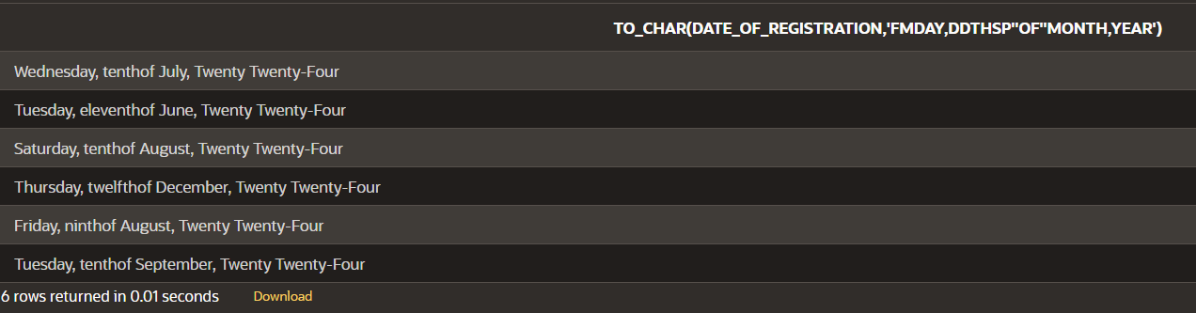

SELECT TO_CHAR(SYSDATE, 'hh:mm')

FROM dual;



SELECT TO_CHAR(SYSDATE, 'hh:mmpm')

FROM dual;



SELECT TO_CHAR(SYSDATE, 'hh:mm:sspm')

FROM dual;



SELECT TO_CHAR(salary, '$99,999') AS "Salary"

FROM Employee;



SELECT TO_DATE('May10,1989', 'fxMonDD,YYYY') AS "Convert"

FROM DUAL;

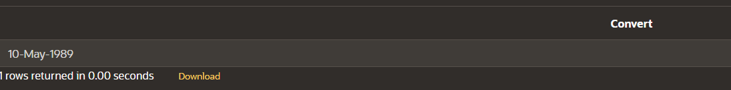

SELECT TO_DATE('July312004', 'fxMonthDDYYYY') AS "Date"

FROM DUAL;



COPYING THE TABLE FROM ANOTHER TABLE :

CREATE TABLE copy_STUDENT3

AS (SELECT * FROM STUDENT3);

DESC copy_STUDENT3;

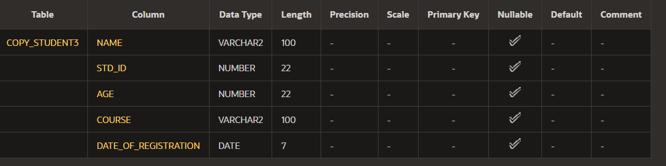

SELECT *

FROM copy_STUDENT3;

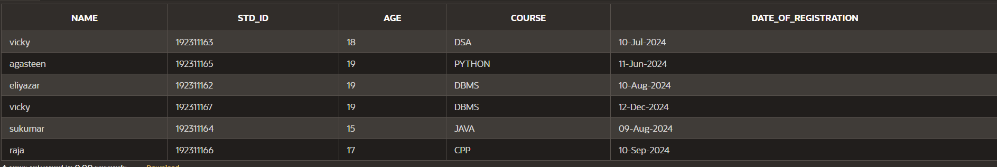

INSERTING THE VALUES INTO THAT COPIED TABLES :

INSERT INTO copy_STUDENT3(name,std_id,age,course,date_of_registration)VALUES ('balu',192311167,20,'JAVA',TO_DATE('12-12-2024','DD-MM-YYYY'));

SELECT *

FROM copy_STUDENT3;

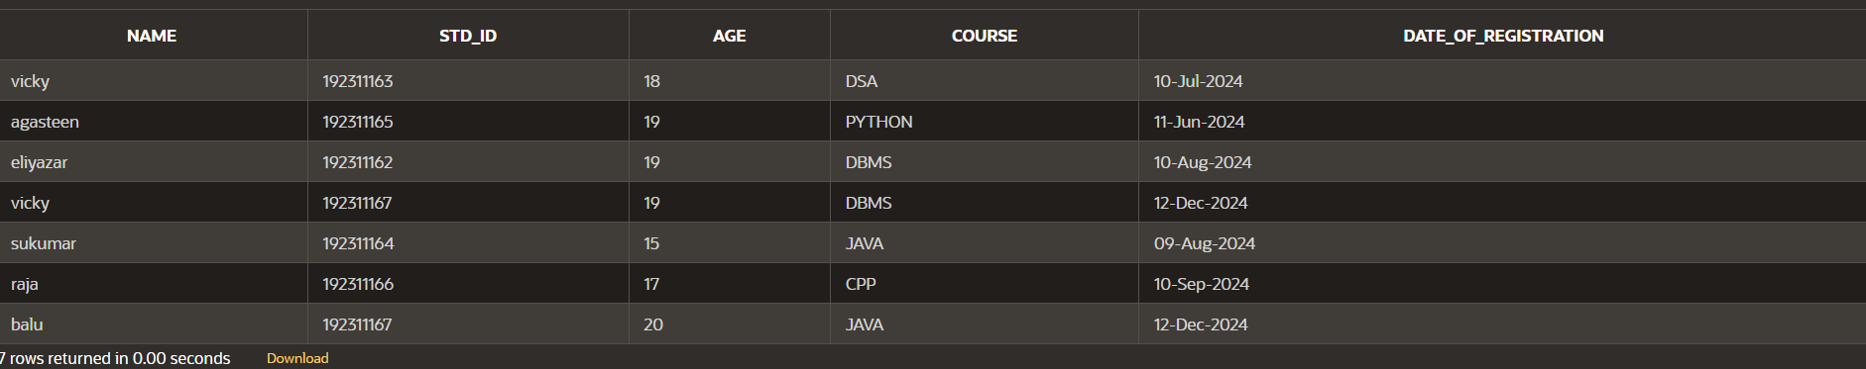

INSERTING NULL VALUES INTO TABLE :

INSERT INTO copy_STUDENT3(name,std_id,age,course,date_of_registration)VALUES ('solmon',192311168,21,'',TO_DATE('12-10-2024','DD-MM-YYYY'));

SELECT *

FROM copy_STUDENT3;

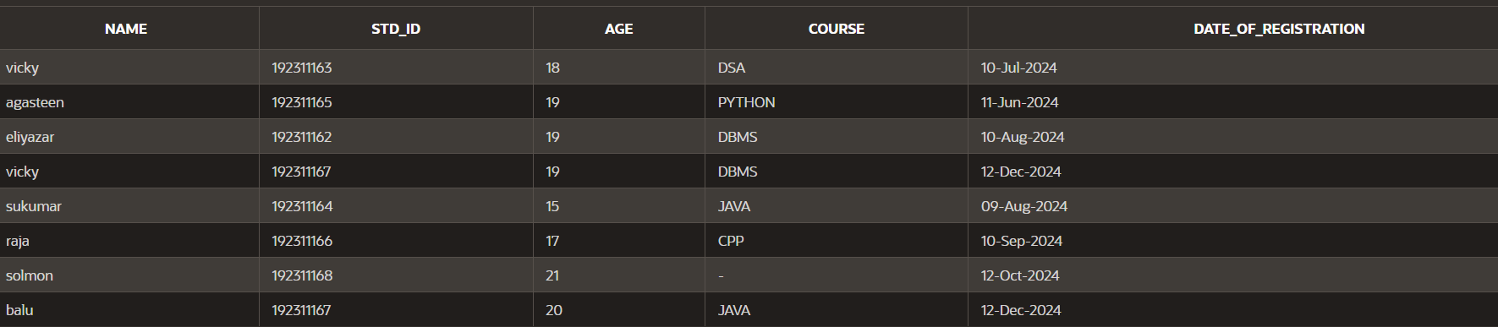

INSERTING SPECIAL VALUES INTO TABLE:

INSERT INTO copy_STUDENT3(name,std_id,age,course,date_of_registration)VALUES (USER,192311169,21,'C',SYSDATE);

SELECT *

FROM copy_STUDENT3

WHERE std_id=192311169;

